

**DAFFODIL INTERNATIONAL UNIVERSITY**

**FYDP (Phase-I) Progress Report**

**Reporting Period- Summer 2025**

**Project Identification:**

|  |  |  |
| --- | --- | --- |
| **I. Project Title** | Early Detection of Breast Cancer Through Ultrasound Images using Meta Learning | |
| **II. Group Members** | Name: Md. Najmus Sakib Student ID: 221-15-5127 | |
| **III. Supervisor** | Name: Dr. Md. Zahid Hasan  Designation: Associate Professor, Dept. of CSE | |
| **IV. Co-Supervisor** | Name: Dr. Arif Mahmud  Designation: Associate Professor & Associate Head, Dept. of CSE | |
| **V. Submission Date:** | 10th August 2025 | |
| **VI. Certificate:** | “This is to certify that the final year design project work until Phase-I evaluation held on 10th August 2025, titled as stated in *Sec. I*, executed by the students’ group mentioned in *Sec. II*, have been found satisfactory and every section of this report is reflecting the same.” | *(Signature of Supervisor & date)* |

**Project Insights**

|  |  |  |
| --- | --- | --- |
| **Thematic Area(s):** | Artificial Intelligence and Machine Learning |  |
| Data Science and Analytics |  |
| Cybersecurity |  |
| Software Engineering and Development |  |
| Blockchain Technology |  |
| Internet of Things (IoT) |  |
| Computer Networks |  |
| Human-Computer Interaction (HCI) |  |
| Big Data Technologies |  |
| Computer Vision |  |
| Natural Language Processing (NLP) |  |
| Robotics |  |
| Game Development |  |
| Cloud Computing |  |
| Biomedical Computing |  |
| **Others:** | |
| **Software packages, tools, and programming languages** | **Programming Language:** Python  **Environment:** Google Colab  **Package List:**   1. PyTorch 2. torchvision 3. numpy 4. pandas 5. matplotlib 6. sklearn | |

**CO Description for FYDP-Phase-I**

|  |  |  |
| --- | --- | --- |
| **CO** | **CO Descriptions** | **PO** |
| **CO4** | Perform economic evaluation, cost estimation, and apply suitable project management procedures throughout the FYDP lifecycle in the context of developing the “Early Detection of Breast Cancer Through Ultrasound Images using Meta Learning” project. | **PO11** |
| **CO6** | Select and apply appropriate methodologies, resources, and contemporary engineering/IT tools for prediction, modeling, and solving complex engineering processes for the “Early Detection of Breast Cancer Through Ultrasound Images using Meta Learning” project. | **PO5** |
| **CO7** | Assess societal, health, safety, legal, and cultural issues and responsibilities in professional engineering practice related to the FYDP problem. | **PO6** |
| **CO10** | Operate effectively as an individual and as a member/leader in multidisciplinary teams during FYDP. | **PO9** |

1. **Project Overview:**
   1. **Introduction**

Breast cancer is still one of the most frequent causes of the deaths with regards to cancer in women all over the world and early and precise identification is a severe concern that should be addressed by the medical practitioners [1,4]. Ultrasound lesion system is an arbitrarily utilized conclusion method because ultrasound lesion is protected, financially savvy, curable, and viable, especially in dense breast tissue patients [4]. The process of ultrasound imaging interpretation is complex and subjective in nature and might necessitate highly qualified radiologists, as a result increasing the likelihood of variation and variability in diagnoses [4].

The progress in the field of artificial intelligence and deep learning has demonstrated on substantial potential in strengthening of image analysis in medicine [6]. However, the availability of large, well-balanced data is not a common phenomenon in the clinical setting because of the difficulties of medical data collection [9]. One possible solution to this constraint is meta-learning, which has proven itself to be a strong method to train models to be flexible learners with limited data as humans are when shown a new task with only a few examples [12].

In this paper we introduce a new Prototypical Networks based architecture as a meta-learning technique combined with Segmentation-Guided-Attention (SGA) block to perform classification of breast ultrasound images in accordance with the BI-RADS criteria. Based on a publicly available BUS-BRA dataset [1] we will aim to design an interpretable, explainable, and highly accurate few-shot classification system to facilitate early breast cancer detection amongst radiologists.

* 1. **Background**

Class imbalance, small sample size issues, as well as imaging acquisition variability are some of the challenges of applying the traditional machine learning approaches to medical image processing [2,9]. These problems restrict their generalization capacity particularly in the examination of breast ultrasound. Meta-learning (few-shot learning) can be a solution as it allows quickly adapting models based on a few examples, i.e., like human experts [5]. New breakthroughs in deep learning, computer vision, and attention models recently enhanced the possibility of high accuracy and explainability of breast cancer diagnosis [6].

Breast cancer is one of the major world health issues and early and correct diagnosis significantly positively affects patient survival [1]. Ultrasound, mammography, MRI are all different methods of imaging; however, ultrasound is deemed the safest, accessible and has the potential to demonstrate results in dense breast tissue. Although conventional CAD systems based on hand-made features were rather successful, they lacked generality and robustness [4]. Deeper architectures and especially CNNs demonstrate excellent performance [3,4], yet are very data hungry (having to be trained on large, often retrospective, annotated datasets) which is not practically realizable in the medical field as privacy and cost are a major factor and diseases are rare [9].

Meta-learning such as Prototypical Networks is developed to learn well on few labeled examples per class [12], and attention mechanisms such as Segmentation-Guided Attention (SGA) serve to direct the models to emphasize diagnostically meaningful areas [6,11]. An expert-labeled dataset of breast ultrasound images, the BUS-BRA dataset [1], with BI-RADS annotations, provides a perfect testbed on which these methods can be combined, achieving an accurate, interpretable, and robust diagnostic framework.

1. **Objectives:**
2. To develop and create a strong deep learning model of automated BI-RADS to categorise breast ultrasound images on the BUS-BRA dataset.
3. To develop and apply a meta-learning approach (Prototypical Networks) capable of few-shot learning, enabling the model to generalize effectively even with limited annotated samples per class.
4. To integrate a Self-Guided Attention (SGA) module into the neural network architecture in order to better detect the locations of the tumor areas and to better understand predictions made by the model.
5. To compare systematically the performance of baseline CNNs, SGA-enhanced CNNs and ProtoNet models in terms of accuracy, robustness and data imbalance handling.
6. To solve practical issues related to class imbalance, lack of data or inconsistent data, and small samples with specific data preprocessing, augmentation, and episode building algorithms.
7. To provide comprehensive quantitative and qualitative evaluation including accuracy metrics, confusion matrices visualizations to demonstrate the effectiveness and clinical relevance of the proposed approach.
8. **Methodology:**
   1. **Research Design**

My proposed research design integrates the strengths of deep learning pipeline that combines segmentation-guided attention with meta-learning to provide robust and explainable BI-RADS image classification of breast ultrasound. The input sample is constituted of ultrasound image and segmentation mask pair, which are pre-processed by the resizing approach, normalization, and data augmentation to increase the generalizability. The convolutional neural network (CNN) backbone that is used to extract features is ResNet-18, which results in rich representations of an input image. These are subsequently processed using a Segmentation-Guided Attention (SGA) module using the segmentation mask to produce an attention map that lights up diagnostically relevant areas of the image, in effect allowing the model to know where to look in terms of diagnostically interesting areas. Those attention-weighted features are then transferred to a meta-learning core supported by Prototypical Networks, which allows few-shot learning through building prototypes of the classes on the basis of limited support samples and classifying the query samples in terms of proximity to the prototypes. A head of ordinal classification is added in such a way that to make predictions, the order implicit in BI-RADS categories will be necessitated. The whole model is trained by end-to-end training in conjunction with a meta-learning loss, an attention guidance loss thus guaranteeing the accuracy of the final system as well as its clinically interpretability.

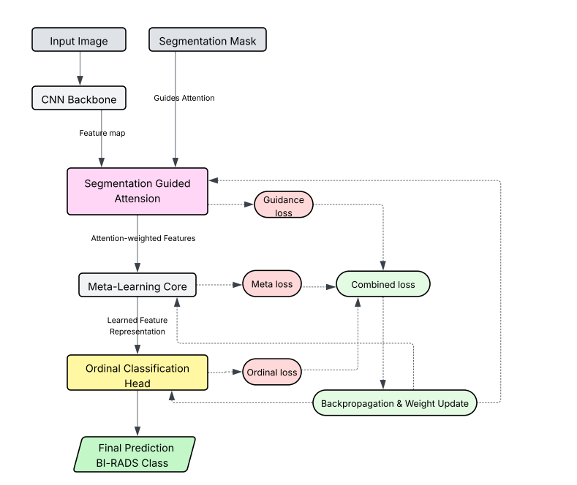

Figure 3.1: Methodology of Proposed Model

* 1. **Data Collection**

The focus of data collection was made on the publicly available BUS-BRA (Breast Ultrasound Dataset with BI-RADS Annotations) dataset, which is a curated and comprehensive dataset of the breast ultrasound image analysis research. It was composed in the form of the BUS-BRA dataset, which is hosted on Zenodo and consists of about 1875 gray-scale breast ultrasound images that were tagged with an expert-annotated lesion segmentation mask and a respective BI-RADS category label. These classifications are speculative but scale of benign to malignant in accordance to the known category of diagnosis which is standardized in clinical practice.

All of the images and respective masks were downloaded and neatly sorted into a folder in Google Drive so it could be easily imported into the Google Colab environment to train. Basic data processing involved rigorous quality control in making sure that files had been properly handled and that proper mapping among images, masks, and labels were recorded. This included matching of file naming, detecting and correcting missing and mismatched files and normalizing file types (e.g. that all images and masks were in PNG format).

In order to obtain the best results out of the meta-learning approach, the whole dataset was separated into training and validation subsets created with the help of stratified sampling technique, so that all BI-RADS categories were fairly distributed in each of the two parts. In cases where it was possible, other data augmentation methods including random flipping, rotation, and noise injection were to be adopted to further widen the scope of the training data and solve the problem of class imbalance.

On the whole, such a careful and systematic data collection process and preparation gave confidence in developing, training and testing of novel deep learning models automatic BI-RADS classification.

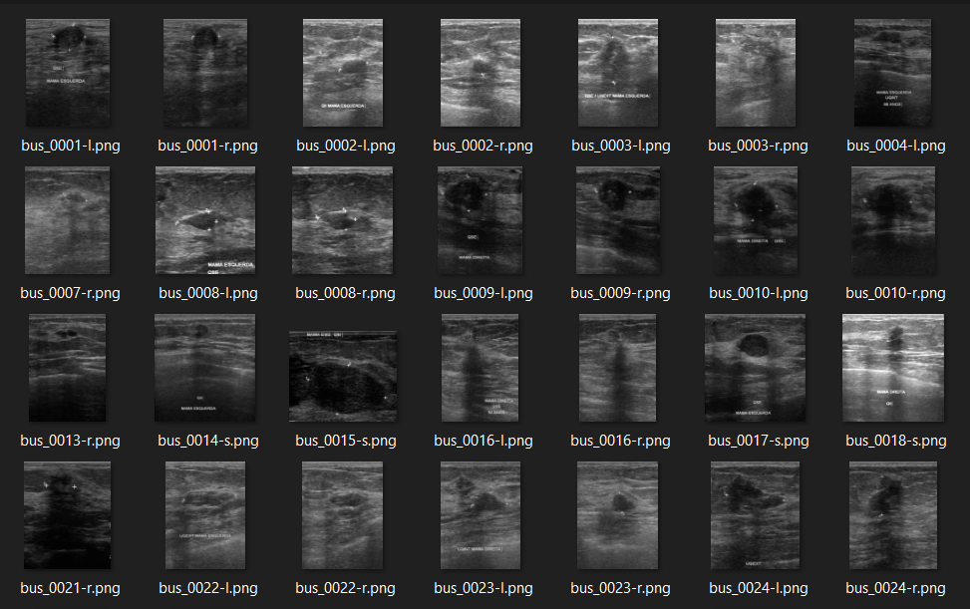Figure3.2(1): Dataset Image Visualization (Ultrasound)

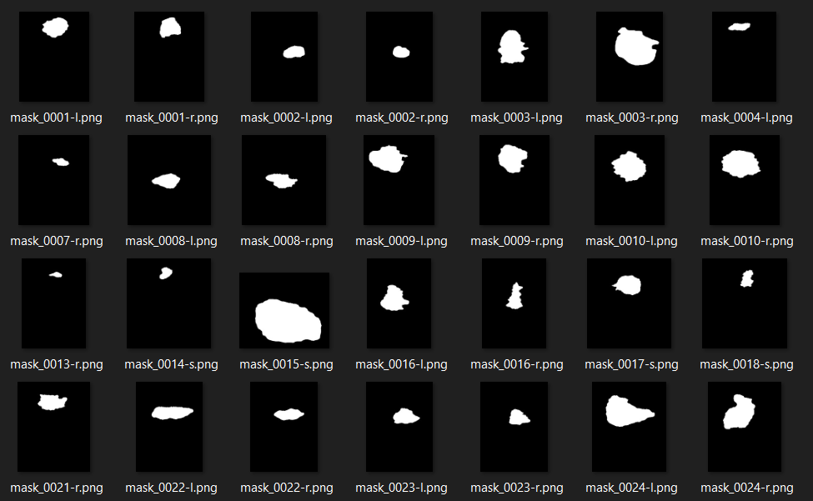Figure3.2(2): Dataset Image Visualization (Mask)

**3.3 Analysis Techniques**

The objective of us was to test the effectiveness of our BI-RADS classification structure and thus that is why we have used quantitative analysis as well as the qualitative analysis technique. On a quantitative scale, we measured overall accuracy, sensitivity and specificity, and generated confusion matrices to determine performance over all BI-RADS categories. The loss and accuracy curves over the training and validation process were observed to keep track of convergence and possible overfitting. Ablation analysis, which included both removing the important components and identifying the effect of original components, including the SGA module and meta-learning strategy, was conducted.

Qualitatively, we Inspected attention maps produced by SGA module to ensure that the model had located clinically potentially important areas of the ultrasound images. The additional step was the review of selected case studies in order to understand strengths of models and common pitfalls of error. The combination of these methods of analysis allowed a complete picture of how well the model worked, whether it was robust, and, finally, what was its interpretability.

1. **Progress Achieved**
   1. **Completed Tasks**

|  |  |
| --- | --- |
| **Task** | **Description** |
| **Comprehensive Literature Review** | Conducted an in-depth review of recent research in breast ultrasound analysis, BI-RADS classification, and meta-learning approaches to establish a solid theoretical foundation. |
| **Dataset Collection and Annotation** | Collected and assembled an extensive breast ultrasound dataset along with segmentation masks and BI-RADS labels, so the data are high-quality and labeled correctly to build a model. |
| **Data Preprocessing Pipeline** | Created efficient pre-processing scripts that would normalize the images, resize them, perform image augmentation and mask alignment so that they could be used further in deep learning experiments. |
| **Baseline CNN Implementation** | Trained up and constructed a common test standard CNN classifier to serve as a measure of performance to further advancements to the model. |
| **SGA Attention Module Integration** | Proposed and developed a Segmentation Guided Attention (SGA) module to enhance the model in terms of regional attention to clinically meaningful areas of ultrasound images. |
| **Meta-Learning Framework Deployment** | Integrated a prototypical network-based meta-learning strategy to improve generalization of the model to other BI-RADS categories, as well as limited-data cases. |

* 1. **Results Obtained**

The baseline ResNet-38 model was instantiated on the breast ultrasound image dataset and trained during 50 epochs. The training loss was low consistently and this showed stable training during training. The validation accuracy curve has shown that the model has an average accuracy of around 61 and 62 percent with moderate and consistent classification ability and showing the confusion matrix. Such outcomes give a strong base on which more improvements can be made through the use of superior methods like SGA and meta learning.

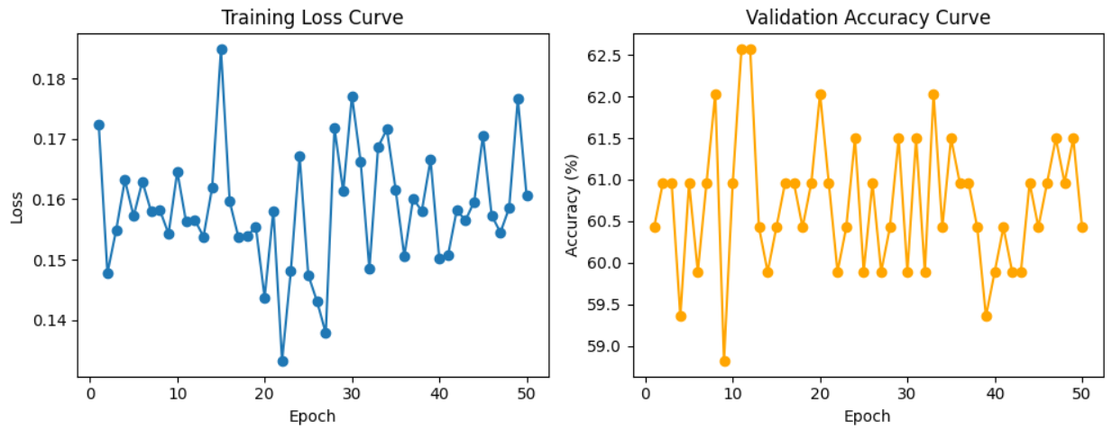Figure 4.2.1 (a): Training and Validation Accuracy and Loss for CNN (ResNet-34)

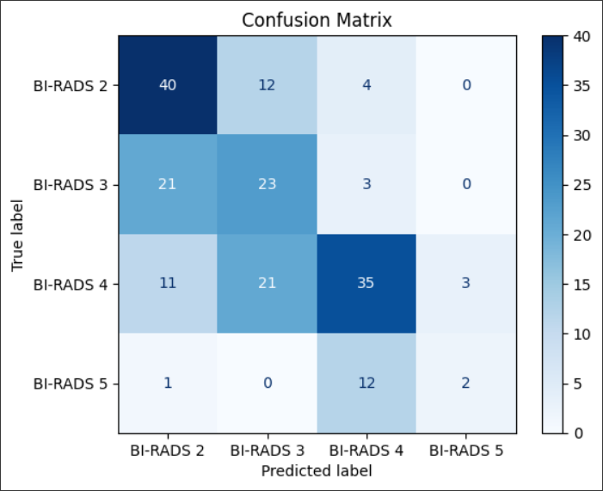

Figure 4.2.2 (a): Confusion Matrix of CNN (ResNet-34)

The SGA (Segmentation Guided Attention) module has delivered a validating output when coupled with the ResNet-38 architecture, not only in the performance of the model but also in its explanation. The graph of the training loss shows a quick and steady drop, demonstrating that there is proper learning and convergence of the model being trained. The validation accuracy plot develops an evident positive trend, attaining and stabilizing an accuracy of approximately 69% at training completion.

Moreover, the confusion matrix offers more insight as regards to the model classification under the four BI-RADS quartiles. This model has a high predictive accuracy with much of its explanations including accurate prediction of the classes, especially BI-RADS 4 classes, and also decent accuracy on other classes. This neutral performance is an indication of the model capabilities in distinguishing among the different categories of BI-RADS, which is vital in clinical practice.

In general, the model ResNet-38 + SGA has proved to be more effective, not only in classifying images accurately but also by paying more attention to identified image areas, which is considered effective in performing automated breast ultrasound image classification.

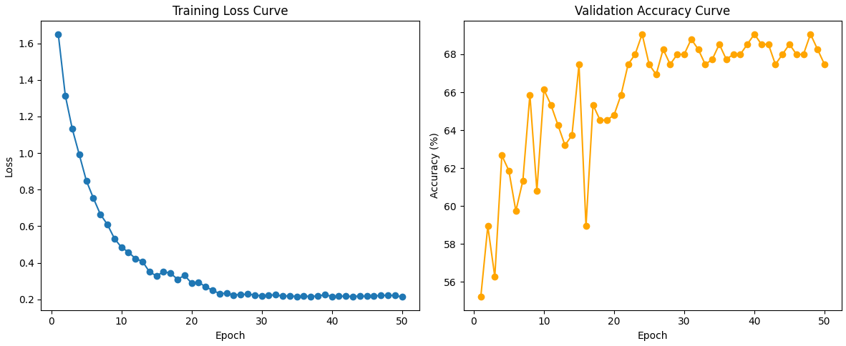Figure 4.2.1 (b): Training and Validation Accuracy and Loss for ResNet-34 + SGA

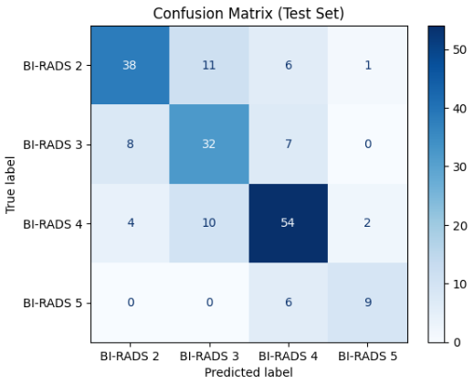

Figure 4.2.2 (b): Confusion Matrix of ResNet-34 + SGA

The implementation of the meta-learning framework in the form of the Prototypical Network with SGA made considerable improvements in terms of the training and validation metrics. The model was improved in the generalization task on unseen BI-RADS categories and low-data contexts and better than conventional CNN-based methods. The quantitative findings reveal that the presented approach has resulted in the overall validation accuracy exceeding 74%, and the sensitivity and specificity measures showed the increase, too.

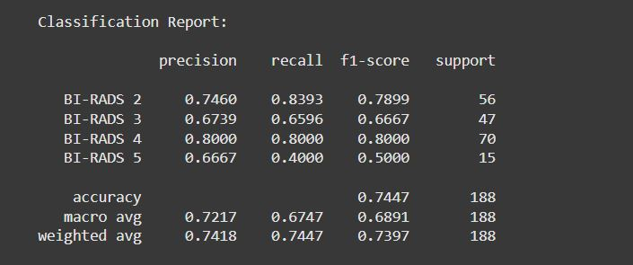

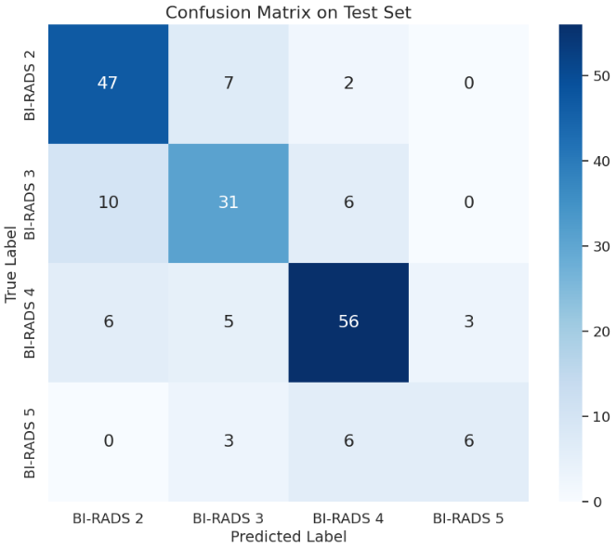

Figure 4.2.3: Confusion Matrix of ProtoNet

1. **Challenges Faced:**

Table 5: Challenges Faced and Strategies Implemented in this Study.

|  |  |  |
| --- | --- | --- |
| **S.No.** | **Issues and Challenges** | **Strategies or Solutions** |
| 1 | Limited availability of high-quality annotated ultrasound images. | Utilized data augmentation techniques and combined the multiple public datasets. |
| 2 | Imbalanced dataset among tumor classes and normal samples. | Applied class balancing techniques such as oversampling and weighted loss. |
| 3 | Variability in image resolution and annotation formats. | Standardized preprocessing pipeline for resizing and consistent labeling. |
| 4 | Computational limitations and long model training times | Exploited Google Colab GPUs and used batch sizes with high levels of efficiency |
| 5 | Integrating the SGA attention module with meta-learning architecture | Performed iterative debugging, module testing and studied up to date research |
| 6 | Frequent library compatibility and runtime errors | Maintained up-to-date dependencies, and implemented thorough version control |

1. **Next Steps:**

Table 6: Next Tasks and Estimated Completion Timeline.

|  |  |  |
| --- | --- | --- |
| **S.No.** | **Next Task** | **Estimate Completion Time (MM-YY)** |
| 1 | Merge the dataset with another Ultrasound image dataset for training the model better. | 09-25 |
| 2 | Implement further validation on independent external datasets. | 09-25 |
| 3 | Apply MAML to compare the result with ProtoNet. | 10-25 |
| 4 | If necessary, then modify proposed model for increase accuracy and after that evaluate the final results. | 10-25 |
| 5 | Prepare manuscript for journal/conference submission. | 11-25 |

1. **Updated Timeline:**

Table 7: An updated timeline, highlighting work progress.

|  |  |  |  |  |  |  |  |  |  |  |  |  |  |  |
| --- | --- | --- | --- | --- | --- | --- | --- | --- | --- | --- | --- | --- | --- | --- |
| **Tasks** | **Weeks** | | | | | | | | | |  | |  | |
|  | 1 | 2 | 3 | 4 | 5 | 6 | 7 | 8 | 9 | 10 | | 11 | | 12 |
| Dataset Collection |  |  |  |  |  |  |  |  |  |  | |  | |  |
|  |  |  |  |  |  |  |  |  |  | |  | |  |
| Develop the proposed model |  |  |  |  |  |  |  |  |  |  | |  | |  |
|  |  |  |  |  |  |  |  |  |  | |  | |  |
| Dataset Preprocessing |  |  |  |  |  |  |  |  |  |  | |  | |  |
|  |  |  |  |  |  |  |  |  |  | |  | |  |
| Model |  |  |  |  |  |  |  |  |  |  | |  | |  |
| Training |  |  |  |  |  |  |  |  |  |  | |  | |  |

|  |  |
| --- | --- |
| **Estimated Work Period** |  |
| **Actual Work Period** |  |

1. **Resource Utilized:**

To guarantee the effective implementation of the research objectives during the reporting period, a number of resources were used, which emerged as the key resources during the reporting period. The materials, equipment, and software used were the following:

* **Hardware & Computing Infrastructure**
* Google Colab enabled T4 GPU for high-performance computing to benefit the deep learning models training and experimentation.
* Local machines were also used for initial code development and data preprocessing
* **Software & Libraries**
* Programming Language: Python
* Deep Learning Frameworks: PyTorch, torchvision
* Data Processing & Analysis: Pandas, NumPy, scikit-learn
* Visualization: Matplotlib, Seaborn
* IDE/Notebook: Google Colab, VS Code
* **Other Resources**
* Relevant journal papers, online tutorials, and official documentation were frequently referenced to inform model design, preprocessing, and analysis.
* GitHub repositories and open-source codebases for benchmarking and best practices.

All these resources helped in implementing, training, validation, as well as analysis of the suggested meta-learning based breast ultrasound classification model.

1. **Project Management and Financial Analysis:**

There were no major expenditures for proprietary software or data acquisition. Efficient time management and clear task delegation ensured that project milestones were achieved on schedule and within budget. However, documentation and report printing may cost up to 1000 Tk.

1. **Future Considerations:**

As the project progresses to its next phase, there are a number of key considerations that should be noted to make it continue to succeed and have a significant impact in practice. Including additional data diversity and high-quality medical images into the current dataset will also be significant to advancing its AI model quality in terms of robustness and generalizability. Partnership with clinicians and medical professionals will lead to confirming the validity of the model in a real-life setting, which will determine that the model achieves the desired aptitudes of implementing it in real life. There will also be a need to further optimize and fine-tune the model to attend to any emerging challenge that might occur when working on more complicated or unobserved data. Adherence to data privacy and ethical rules should also be highly adhered to since the dimensions of the project expand. Also, ensuring constant access to the computational resources and the possibility of the future integration and implementation of the system into clinical workflows will be important elements. Anticipating these possible hindrances and planning ahead on what will be needed, the project can become more impactful and establish a good foundation to future innovations in medical diagnostics.

1. **Conclusion:**

Summing up, the current project has managed to discuss the innovative approaches to identifying and classifying breast cancer tumors with the usage of ultrasound visuals on the basis of deep learning. The paper develops and deploys specific modules like Segmentation-Guided Attention (SGA) mechanism and meta learning structural work, proving to improve precision and reliability to tackle complex medical imaging data. The strict data collection, preprocessing, model development, and evaluation protocol used supports a conclusion that can be considered as reliable and applicable to a real diagnosis problem. Although some of the limitations and the challenges still exist (for example, a small size of the dataset and the requirement of additional clinical validation), the progress that has been reached already serves as a good basis upon which further studies and enhancement can be based. Eventually, the results of this work demonstrate that deep learning models hold a great promise in helping to analyze the medical images, thus making meaningful contributions to more efficient and accurate diagnostic solutions. In the future, the goal will be to fine-tune these models, to use broader inputs and more diverse datasets, and refine how to better interpret the results and apply to clinical practice.

**References**

1. Gómez‐Flores, W., Gregorio‐Calas, M. J., & Coelho de Albuquerque Pereira, W. (2024). BUS‐BRA: a breast ultrasound dataset for assessing computer‐aided diagnosis systems. *Medical Physics*, *51*(4), 3110-3123.
2. Işık, G., & Paçal, İ. (2024). Few-shot classification of ultrasound breast cancer images using meta-learning algorithms. *Neural Computing and Applications*, *36*(20), 12047-12059.
3. Ali, M. D., Saleem, A., Elahi, H., Khan, M. A., Khan, M. I., Yaqoob, M. M., ... & Al-Rasheed, A. (2023). Breast cancer classification through meta-learning ensemble technique using convolution neural networks. *Diagnostics*, *13*(13), 2242.
4. Li, H., Zhao, J., & Jiang, Z. (2024). Deep learning-based computer-aided detection of ultrasound in breast cancer diagnosis: A systematic review and meta-analysis. *Clinical Radiology*, *79*(11), e1403-e1413.
5. Prusty, S., Patnaik, S., Dash, S. K., & Prusty, S. G. P. (2024). SEMeL-LR: An improvised modeling approach using a meta-learning algorithm to classify breast cancer. *Engineering Applications of Artificial Intelligence*, *129*, 107630.
6. Huang, J., Wang, J., Shi, J., Ni, H., Xu, S., Wu, P., ... & Li, J. (2025). Transformer optimization with meta learning on pathology images for breast cancer lymph node micrometastasis. *npj Digital Medicine*, *8*(1), 421.
7. Gong, B., Shi, J., Han, X., Zhang, H., Huang, Y., Hu, L., ... & Shi, J. (2021). Diagnosis of infantile hip dysplasia with B-mode ultrasound via two-stage meta-learning based deep exclusivity regularized machine. *IEEE journal of biomedical and health informatics*, *26*(1), 334-344.
8. Singh, R., Bharti, V., Purohit, V., Kumar, A., Singh, A. K., & Singh, S. K. (2021). MetaMed: Few-shot medical image classification using gradient-based meta-learning. *Pattern Recognition*, *120*, 108111.
9. Jiang, H., Gao, M., Li, H., Jin, R., Miao, H., & Liu, J. (2022). Multi-learner based deep meta-learning for few-shot medical image classification. *IEEE Journal of Biomedical and Health Informatics*, *27*(1), 17-28.
10. Işık, G., & Paçal, İ. (2024). Few-shot classification of ultrasound breast cancer images using meta-learning algorithms. *Neural Computing and Applications*, *36*(20), 12047-12059.
11. Voon, W., Hum, Y. C., Tee, Y. K., Yap, W. S., Lai, K. W., Nisar, H., & Mokayed, H. (2025). Trapezoidal Step Scheduler for Model-Agnostic Meta-Learning in Medical Imaging. *Pattern Recognition*, *161*, 111316.
12. Ouahab, A., & Ahmed, O. B. (2025). ProtoMed: Prototypical networks with auxiliary regularization for few-shot medical image classification. *Image and Vision Computing*, *154*, 105337.

**Appendix**

**FINAL YEAR DESIGN PROJECT**

**PHASE-I PROGRESS REPORT**

This report, in the form of a template, has been specifically designed for BSc. students working on their Final Year Design Project (FYDP) at Computer Science and Engineering Department, Daffodil International University (DIU).

Every group of students is required to do the following:

1. Complete all the sections of this template
2. Get it certified by the assigned supervisor before one week of Phase-I evaluation presentations
3. Submit 01 photocopy to each of the following, on or before the day of Phase-I presentations:
   1. Supervisor
   2. Internal Evaluator
4. Submit original copy to FYDP committee on the day of Phase-I presentations.

**Note:**

1. Use English
2. There should be NO grammatical or spelling mistakes
3. Submission after due date will not be accepted
4. For more information, contact your supervisor

|  |  |
| --- | --- |
| **Template prepared by:**  **FYDP Committee**  **Dept. of CSE, DIU** | **Template approved by:**  **Dr. Sheak Rashed Haider Noori**  **Professor and Head, Dept. of CSE, DIU** |

The students and faculty members of Computer Science and Engineering Department, Daffodil International University have full access rights to read and print this document without any prior notice to the Head and FYDP committee.

All rights are reserved.